**REDX**

Transporters

In 3rd meeting we all discussed about the problem statement.. We have come to conclusion that during wari medical issues are being there and due to traffic ambulance are unable to reach at short time, so we all are going to work on that.  
At first for traffic management we all have thought about the following problem solution:

1)One of the solutions was to take data from the pmpml and display it on the screen.

2)To gather the information of the pindis and show them the way to their stop.  
3) To clear the roads of traffic for an emergency vehicle.  
4) One of the ideas are to avoid accident of warikaris when they come across the truck they may be crushed under the tire so we can have sensor on the front side of the trucks which will detect humans and give a signal to the driver so that he will break.  
5) Showing live Darshan for the people who only want the Darshan without visiting the temple. This will help us to solve the problem of excessive crowd.  
6) Sensors should be planted at some distance from the signals and they should be connected to signals.. If numbers of vehicles on one of the side increases then the signal time will be set according to that and if vehicles are less signal time will decrease.

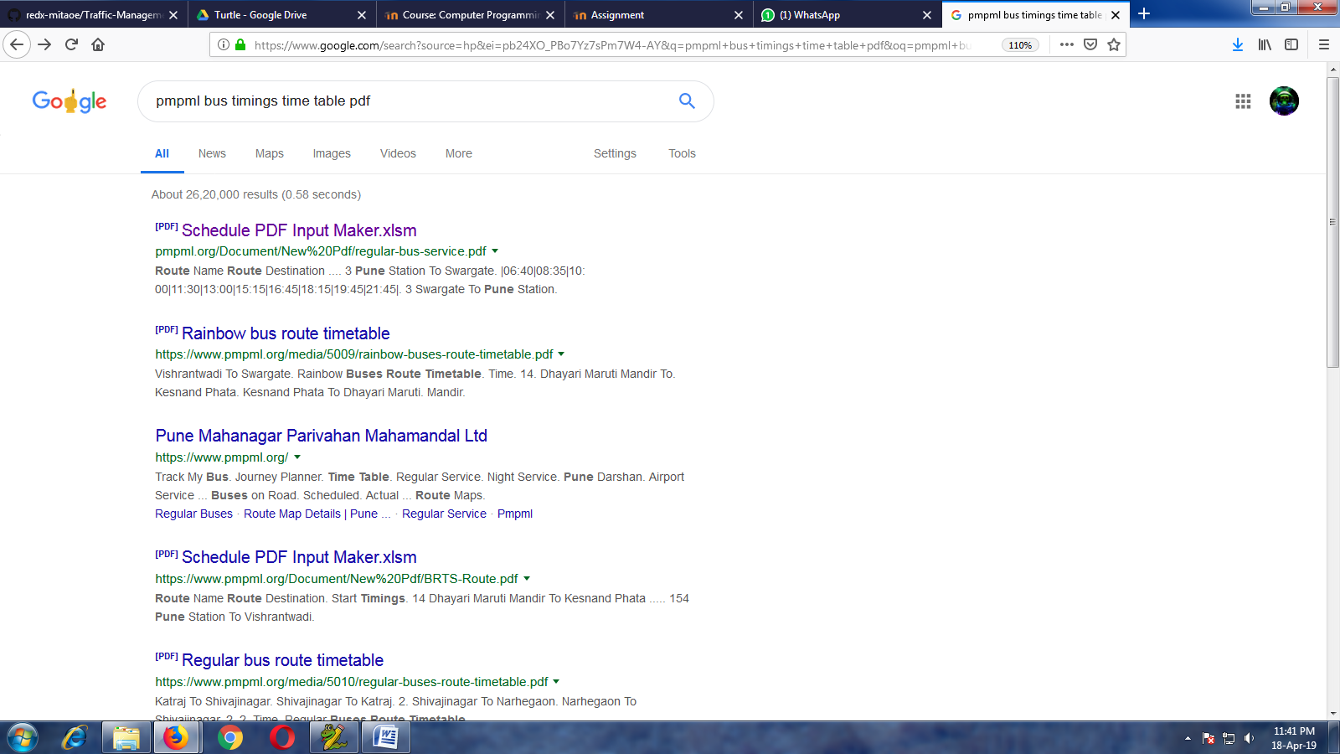

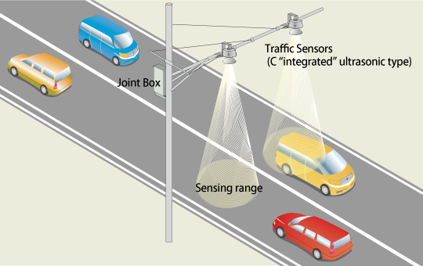

s